DIGITAL MARKETING

Assignment 2- Create a facebook page and posting a social media

Poster

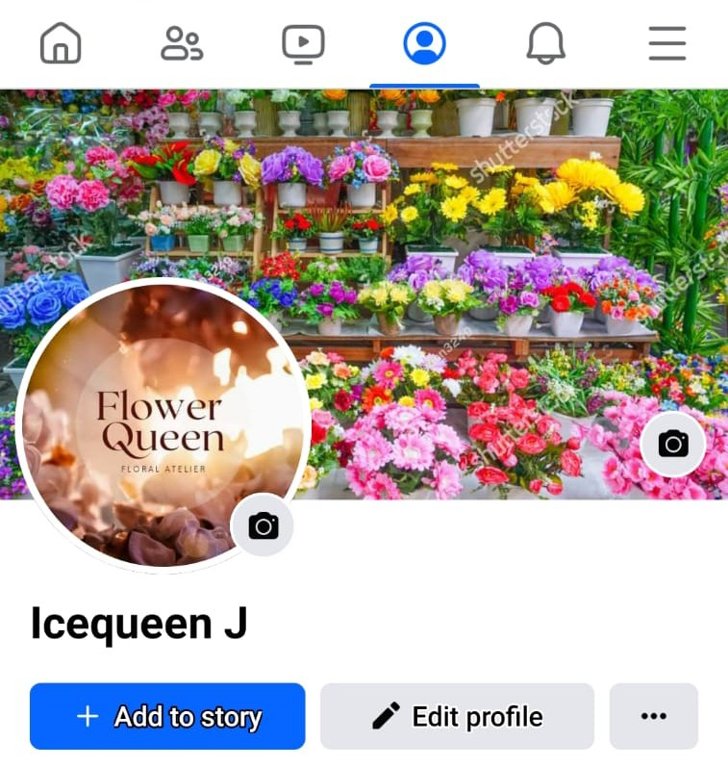

Figure: facebook profile

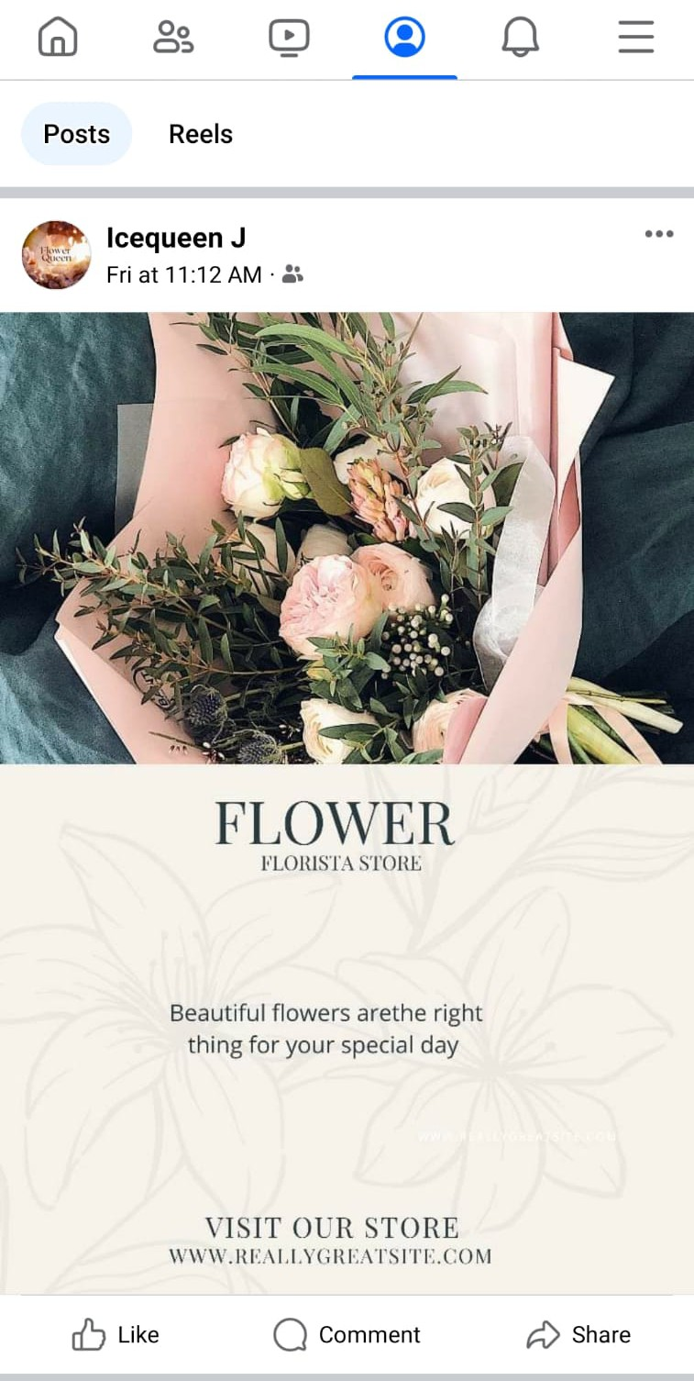

Figure: Social media poster

Facebook post link:

<https://m.facebook.com/story.php?story_fbid=pfbid0JfrXM2BWSqdNGEJT9yZJHrx79c4koSFd6B1KpMsbnKXXAM726JwgRgfSH6c4hMGWl&id=61552906377110&mibextid=Nif5oz>